Security Selection

1. Fundamental Analysis

**Top Down Analysis**

* ***Step 1 Domestic and global economy***

Sensitivity of the firm’s CF to the economy

or used as a benchmark for forecasting

To assess, we look at :

Inflation, taxation, GNP, consumer confidence index, foreign exchange, political risk...etc

* ***Step 2 Industry analysis***
* Share of the market
* If Cyclical Industry, look at the stage cycle

e.g Car, Heavy equipment

Start-up 🡪 High Sales

Consolidation 🡪 Stable Sales

Maturity 🡪 Declining Sales

Declining 🡪 Minimal Sales

* If not cyclical : growth or defensive industry

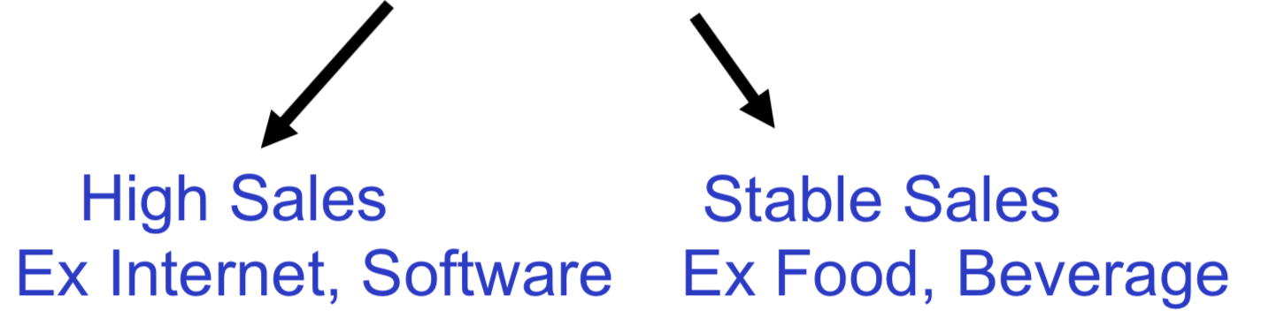

* ***Step 3 Company analysis***
* First, look at the past performance:

weak or strong financial statements?

Use Ratio Analysis

Liquidity Ratios

Ability to pay bills, usually prefer CA/CL

Debt Ratios

Use of debt? ..►Financial distress

Profitability Ratios

Ability to generate profit

Efficiency Ratios

Use of assets (or turnover)

Compare to the average or overtime

Strong F/S: High liquidity, low debt, good profit, high efficiency

* Second, look at the future prospects to value the stock price using the CFs fundamentals of the firm

**A. DCF**

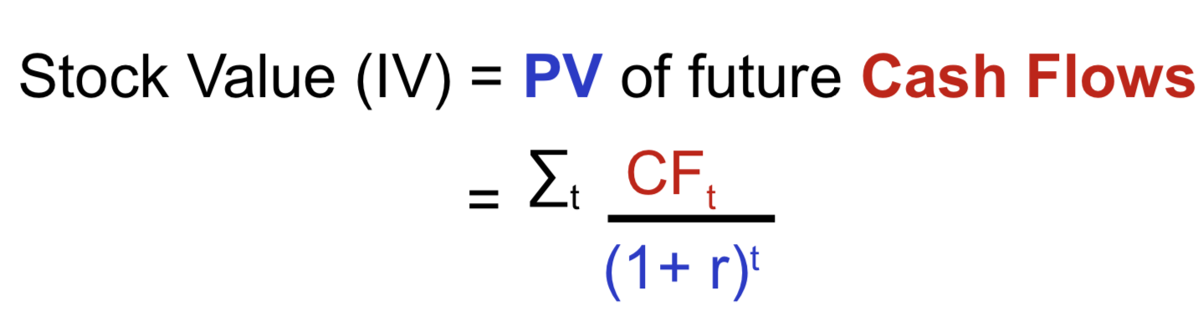

r: reflects the risk of Cash flows  
t: Foreseeable CF between 5-10 years unless .. (mining: better forecast)

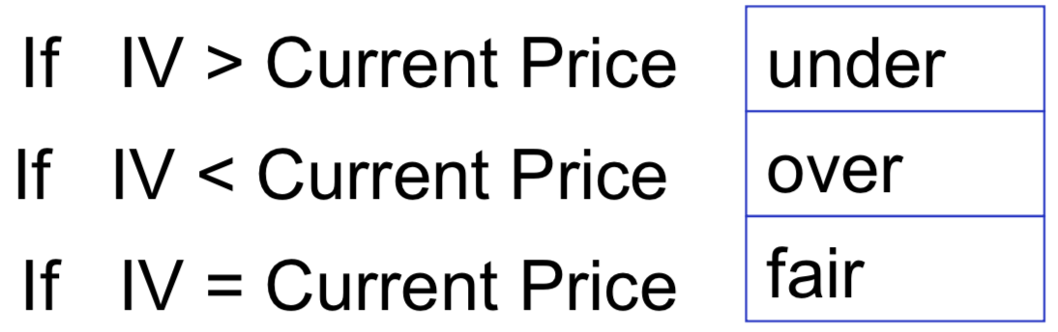

* **A.1 Dividend Discount Model (DDM)**

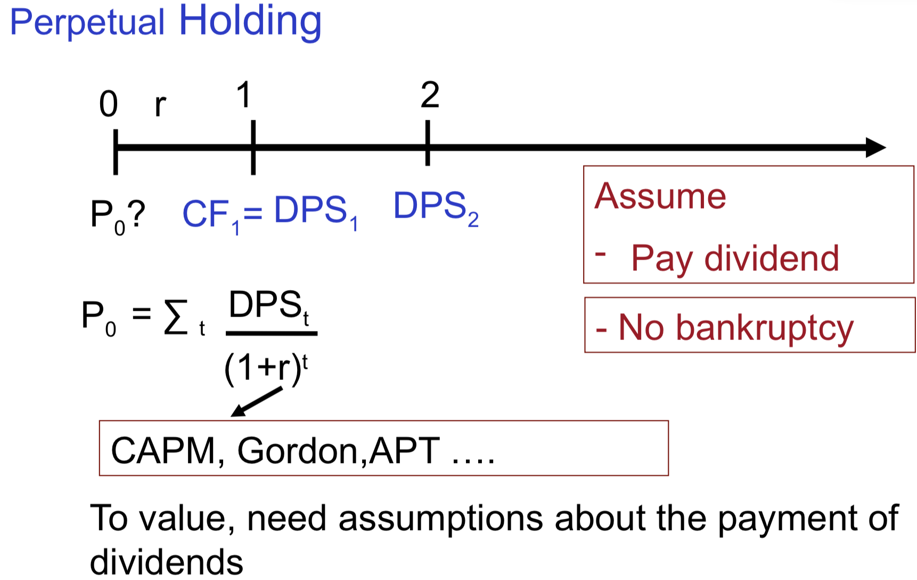

Doesn’t suitable for technology stocks (They don’t have a policy to pay dividends)

Only for DENFENSIVE stocks

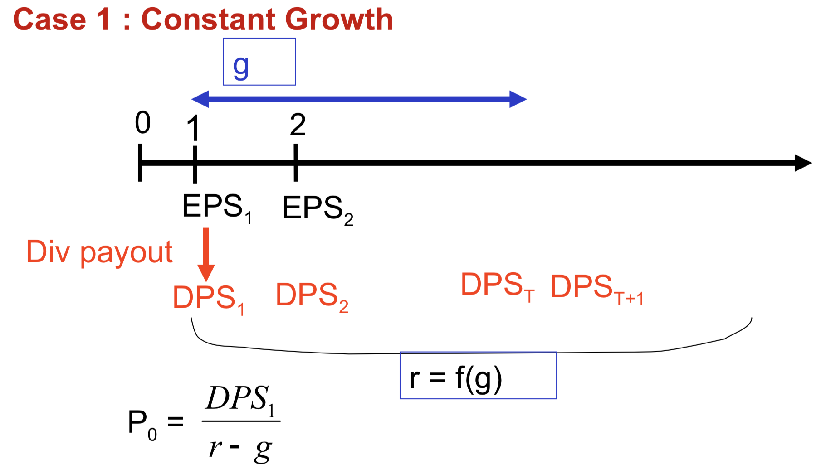

Gordon r = D1/P0 +g

g: Steady state - stable/normal growth rate

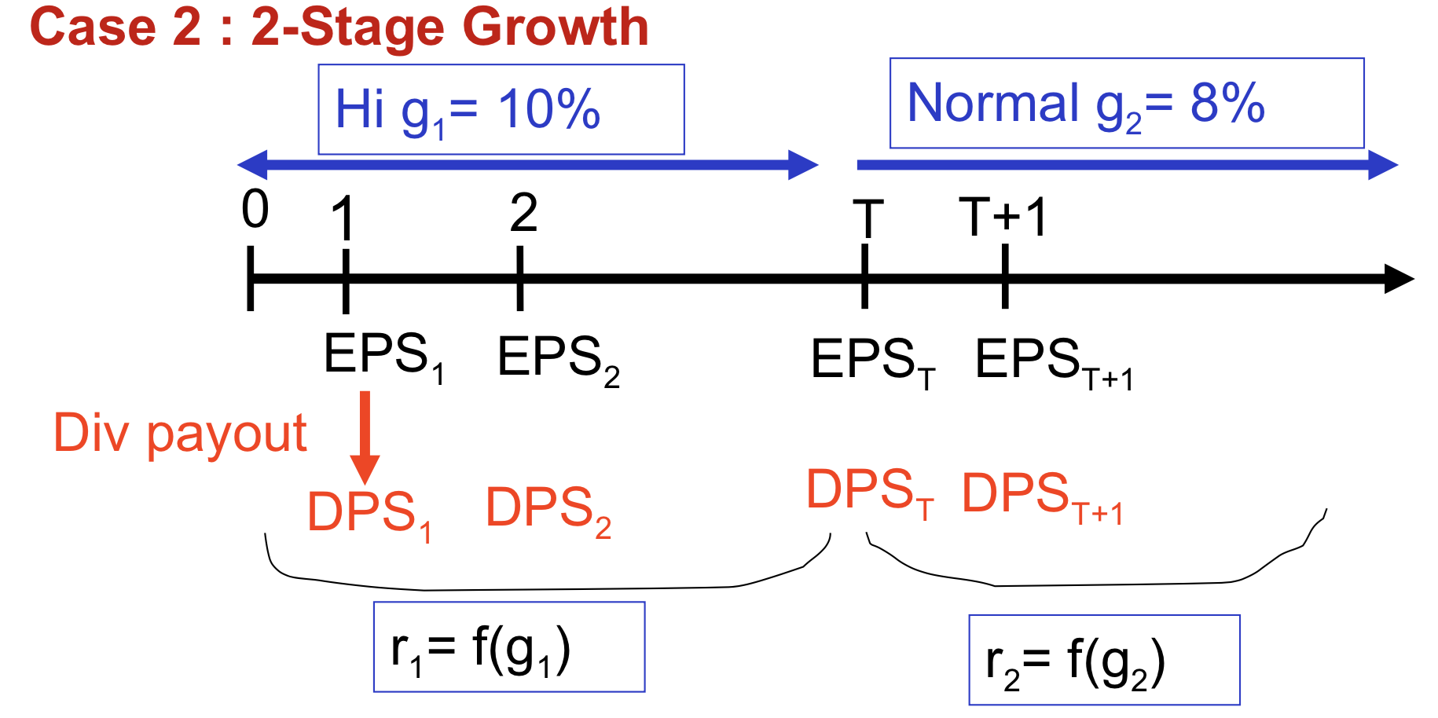

g1: abnormal growth rate 🡪 r1 should be higher (more risky)

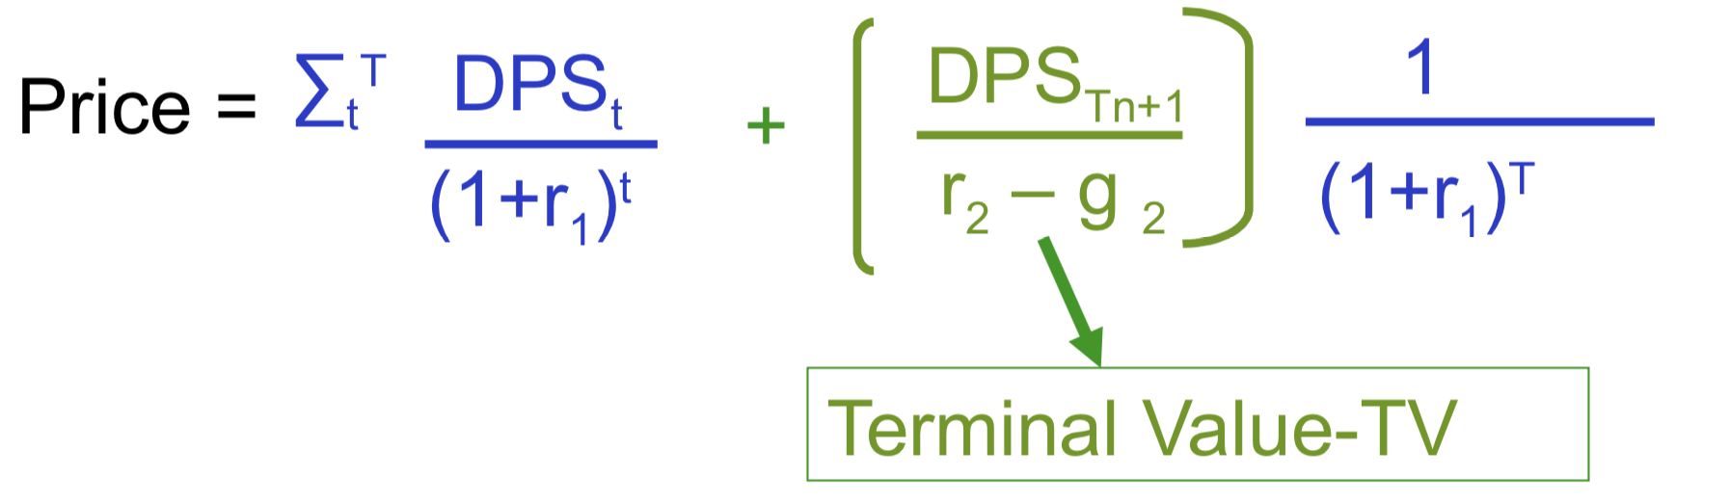

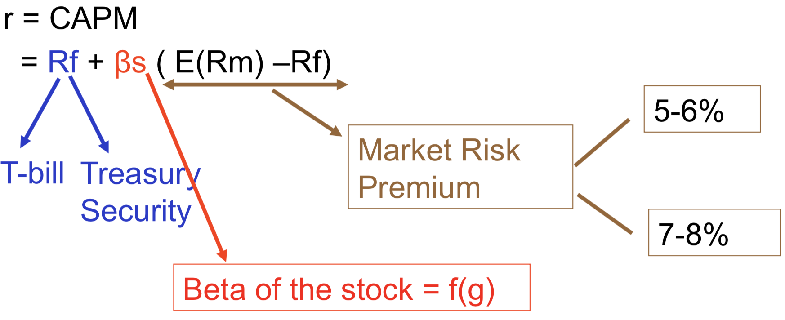

🇨🇦 less diversified

🇺🇸

T-bond: long-term, preferable

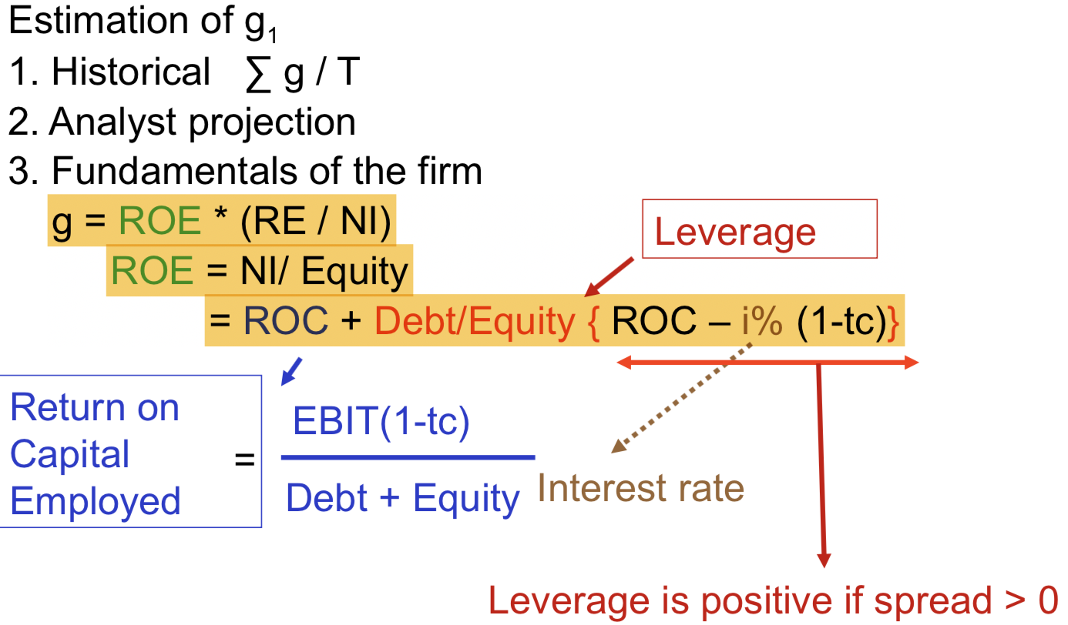

ROE : return on equity

RE: retained earning

the higher RE, the faster growth

NI: net income

after-tax interest rate

operating assets

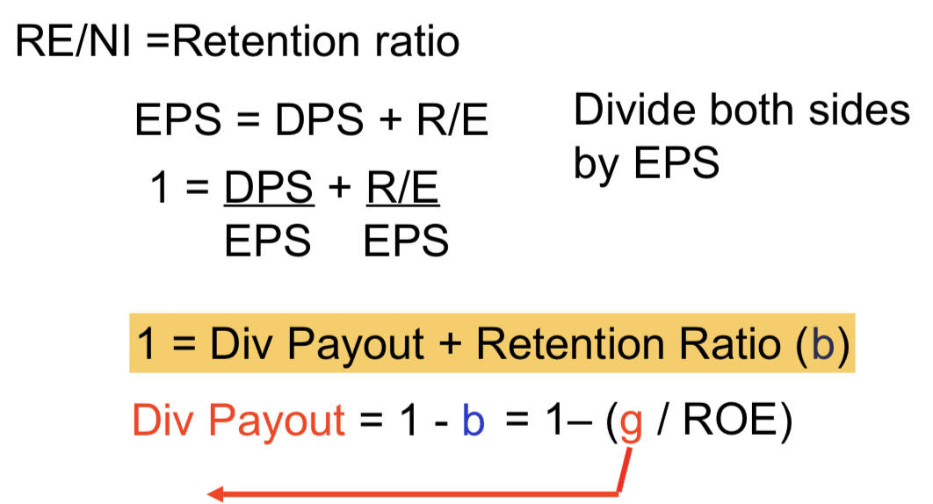

The higher dividend, the lower the growth.

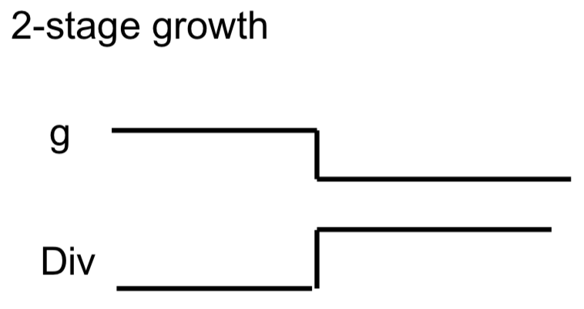

<Example>

2-stage growth, MRP(market risk premium)=5.5%, Tc=36%, EPS =$2.7, Rf=8.5%

|  |  |  |
| --- | --- | --- |
| Input | High g | Low g |
| Time | 5 years |  |
| g | 13.04% | 6% |
| Beta | 1.45 | 1.1 |
| ROC | 12.5% | 12.5% |
| Payout | 33.33% | 69% |
| Debt/Equity | 1 | 1 |
| r | 15.48% | 13.55% |
| Borrowing rate | 8.5% | 8.5% |

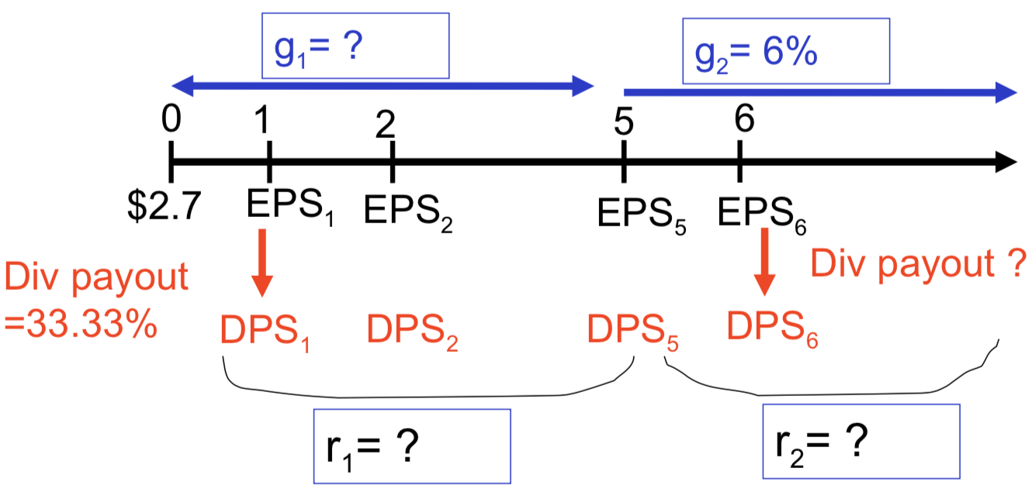

step 1 g1 = ROE*b

= {ROC+Debt/Equity*(ROC-i%*(1-Tc))}*(1-DivPayout)

= 19.46%*0.67

= 13.04%

step 2 DivPayout in stage 2 = 1-b

= 1- 6%/19.36%

= 69%

step 3 r1=7.5%+1.45*5.5%=15.48%

r2=7.5%+1.1*5.5%=13.55%

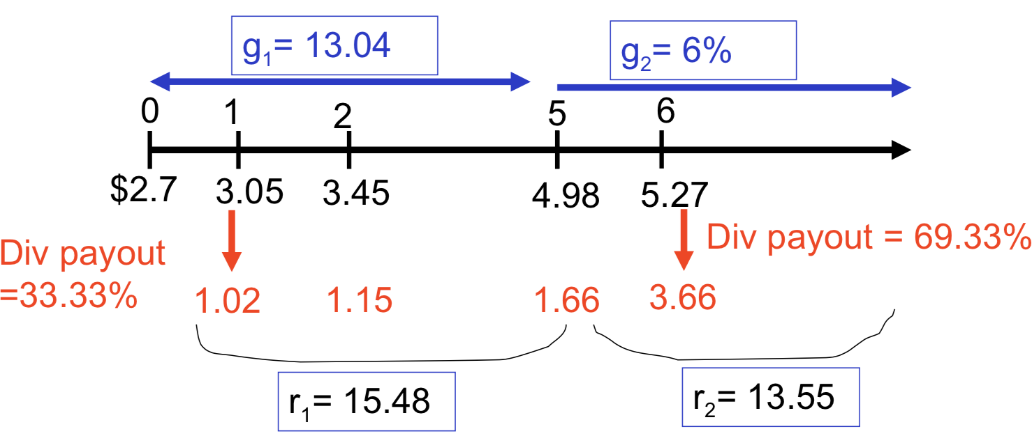

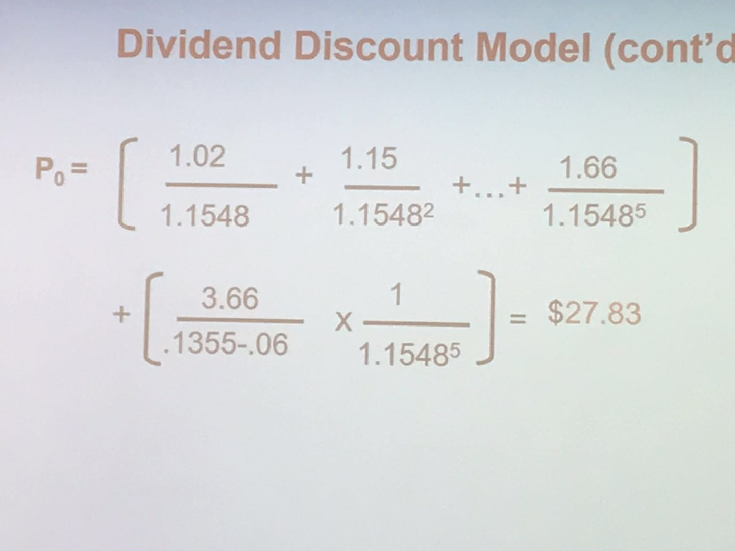

vs Current price=$35 (overpriced🡪sell)

* **A.2 Free Cash Flow to Equity**

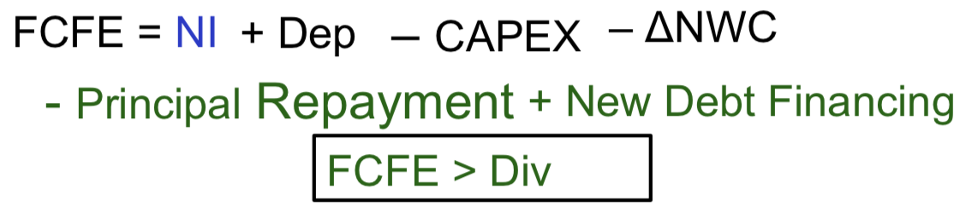

FCFE is a better measurement of values

Special Case

Define Net CAPEX = CAPEX-Dep

If Net Capex and ΔNWC are expected to be financed are expected to be financed at some target debt ratio δ (delta) and principal payments are made from new debt issue

FCFE = NI – (1- δ) Net CAPEX – (1- δ) ΔNWC

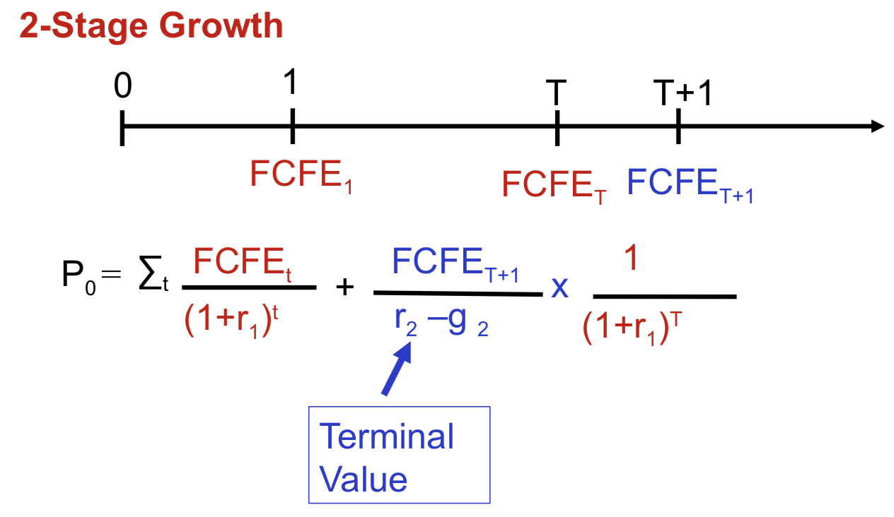

* **A.3 Free Cash Flow to Firm**



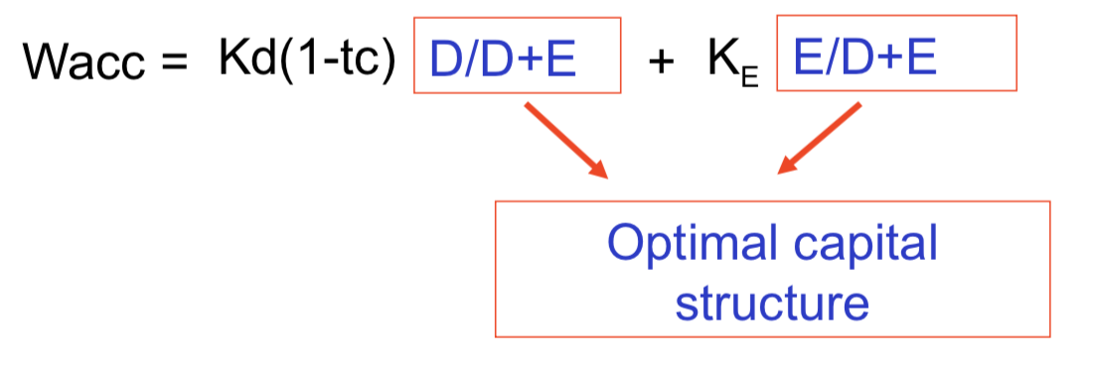

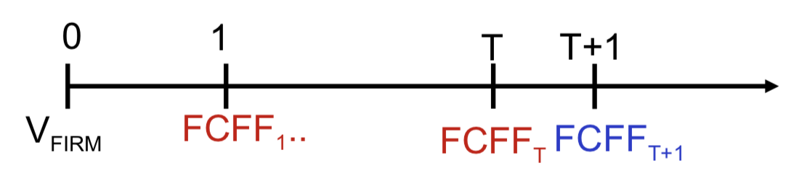

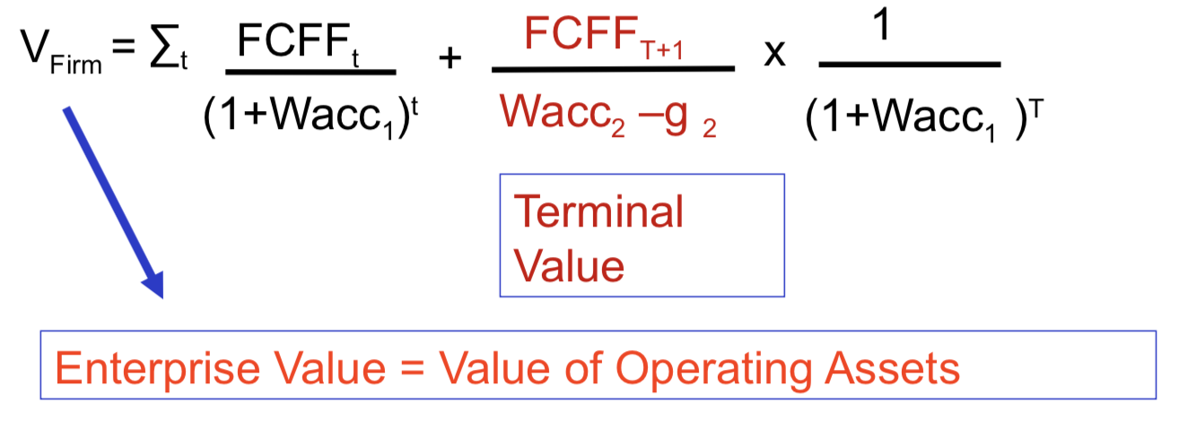

Equity = VFirm- Debt

Share Price = Equity/ # Shares

What if we have non operating assets?

VFirm = Value of Operating + Non Operating Assets

What if we have Preferred Stock?

Equity = VFirm – Debt - PS

Wacc=Kd(1-tc)(D/D+PS+E)+ Kps(PS/D+PS+E) +KE (E/D+PS+E)

**B. Multiples ~ Relative Valuation**

* Equity Value Multiple

Price ≈ M * Target

* Earnings

Price ≈ P/EPS * E(EPS) If positive earnings

* Sales

Price ≈ P/S * E(S) If negative earnings (Technology)

* Book Value

Price ≈ P/BV * E(BV) If negative earnings but not technology(distressed business)

ii. Explaining P/BV

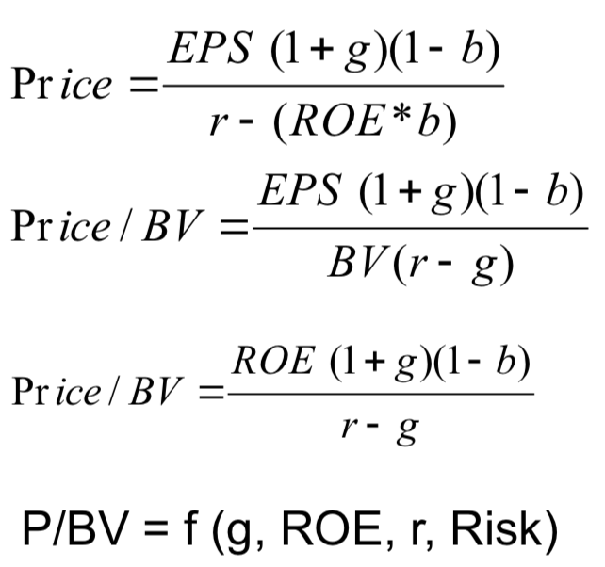

iii. Explaining P/Sales

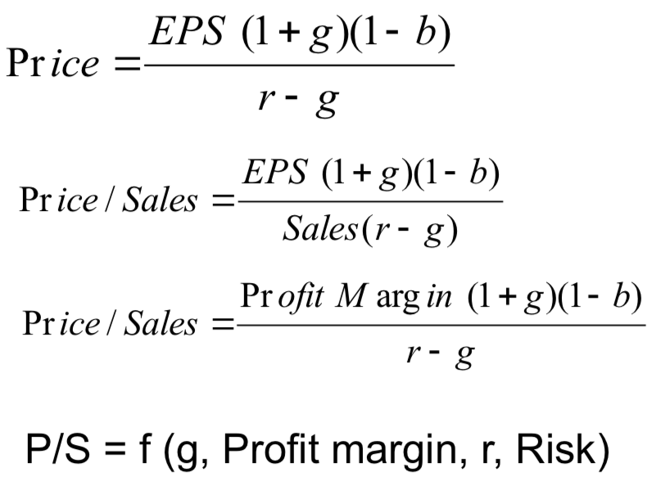

<Summary>

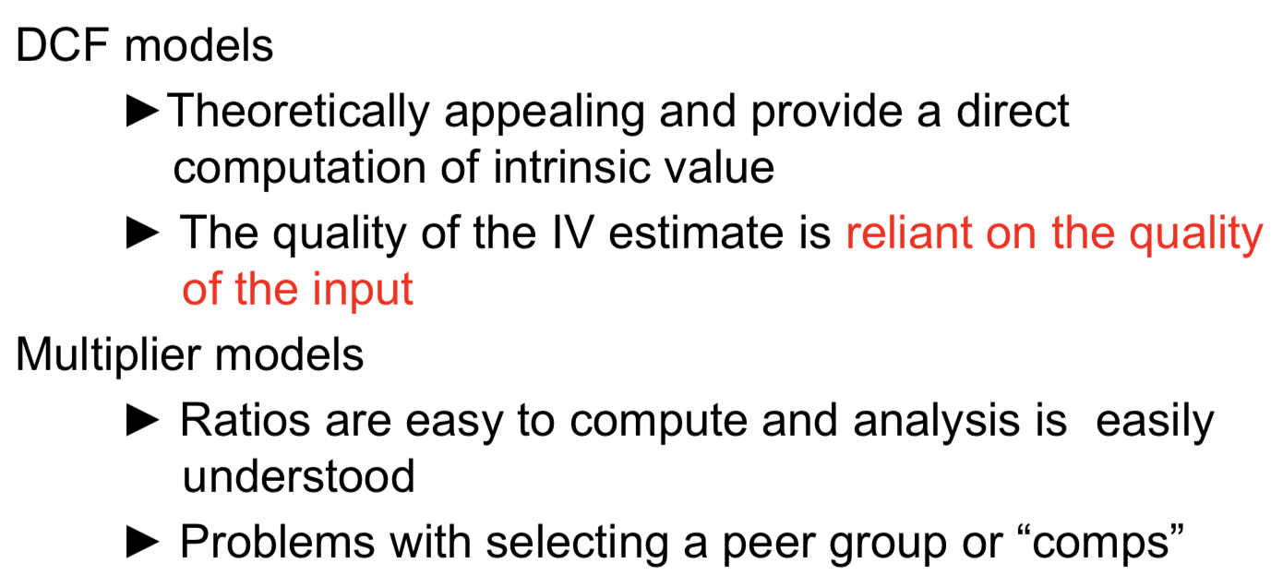

2. Market Efficiency

Definition

A stock market is efficient if stock prices reflect all available information

►You cannot make extra profit using any source of information

A stock market is efficient with respect to a set of information

Implicit concept

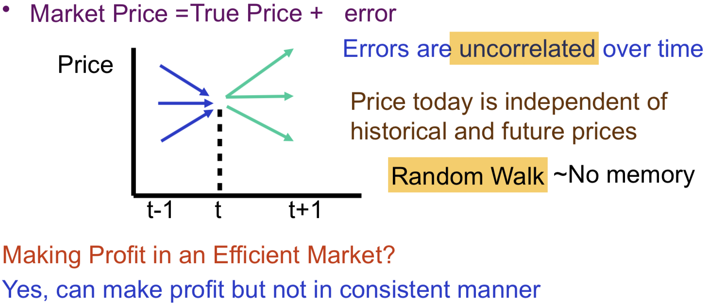►Luck

Source of market efficiency

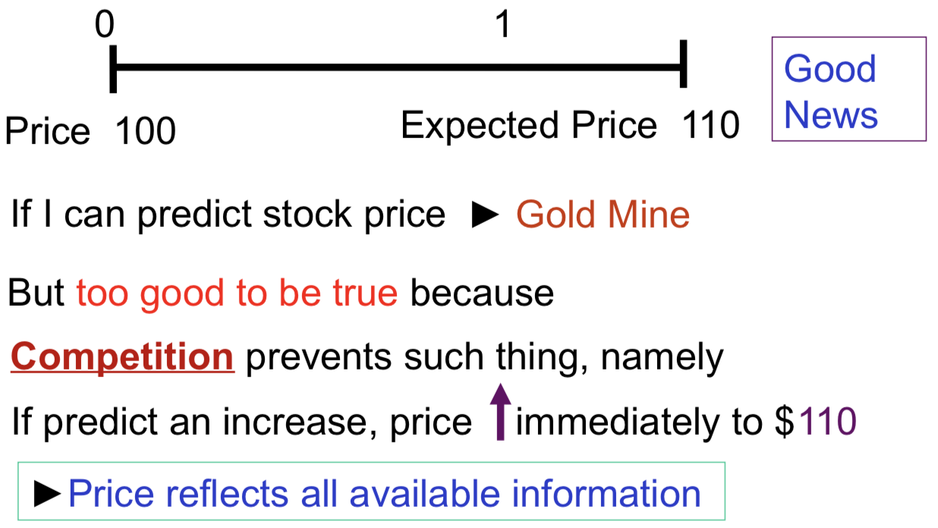

**A. Classification of Market Efficiency**

* **Weak Form Efficiency**

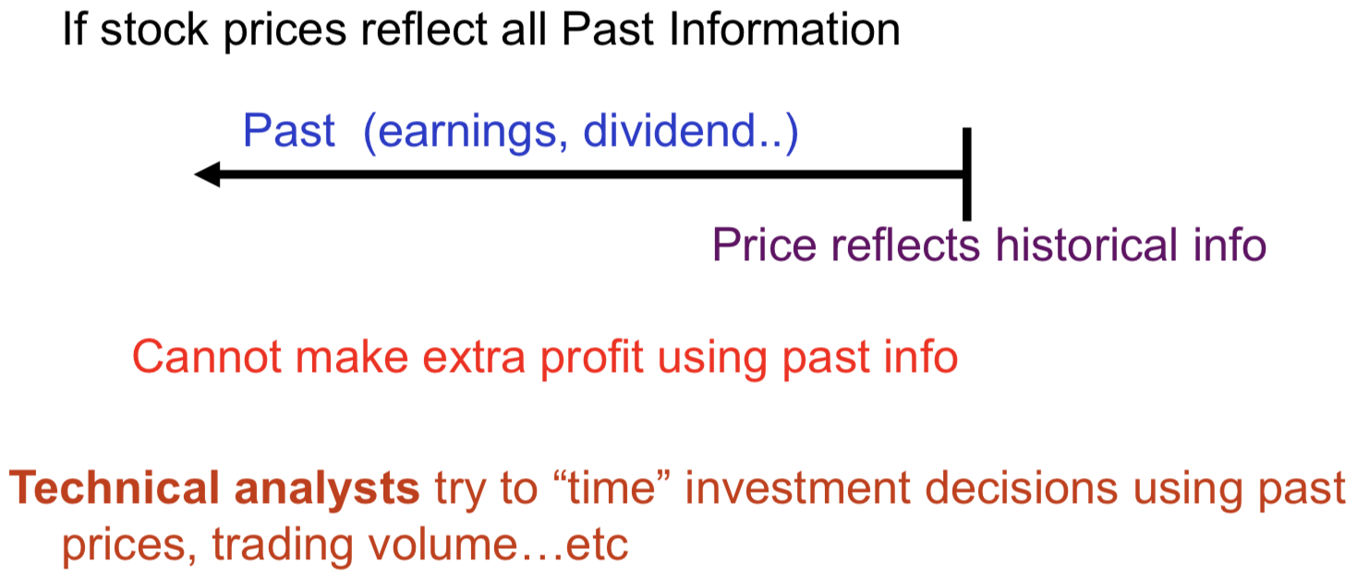

**[Technical analysis]**

* **Price Momentum**

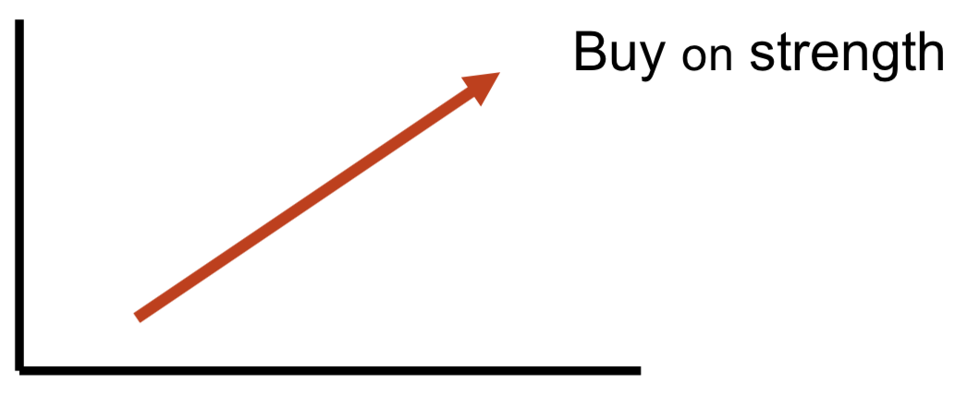

* **Moving average**

*The moving average is the average level of prices over a given interval of time*, where the interval is updated as time passes; Average calculated on last n periods such as 100-day or 50-day

Predict price change if prices cross the average

When market price breaks through the moving average line from below, it is time to buy

When prices fall below the moving average, it is time to sell

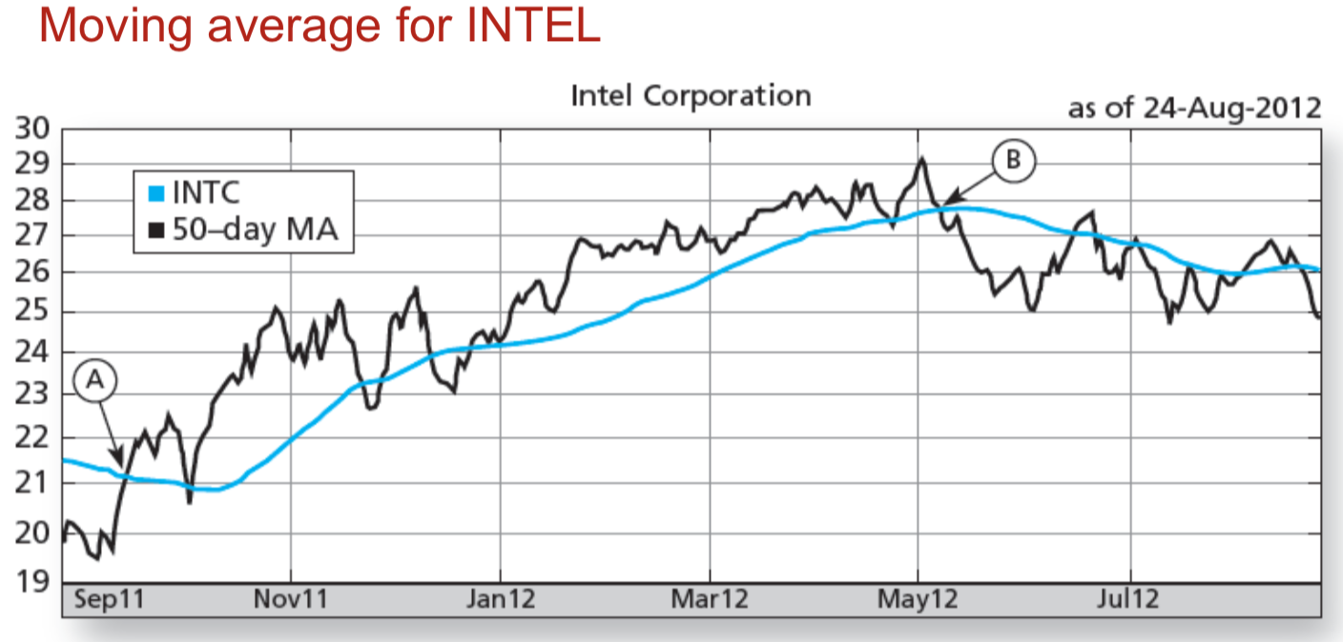

* **Head & Shoulders Move**

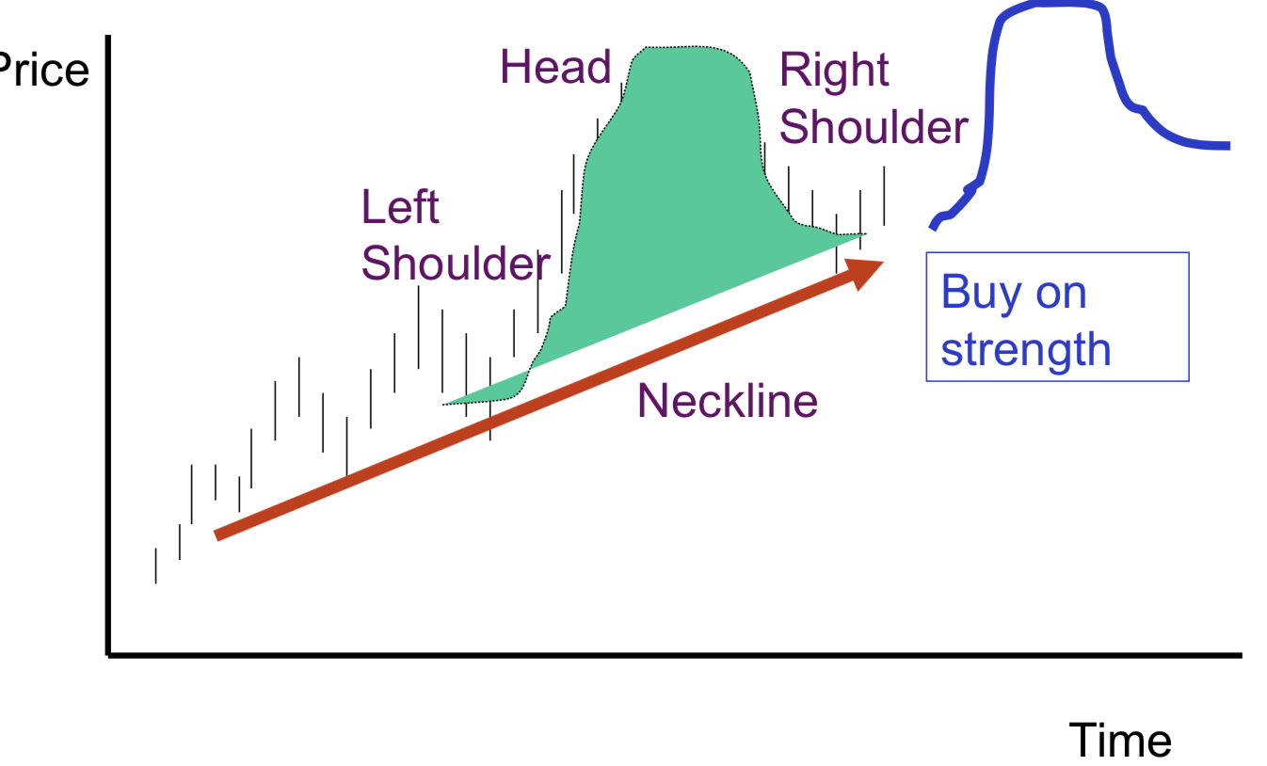

* **Support & Resistance Levels**

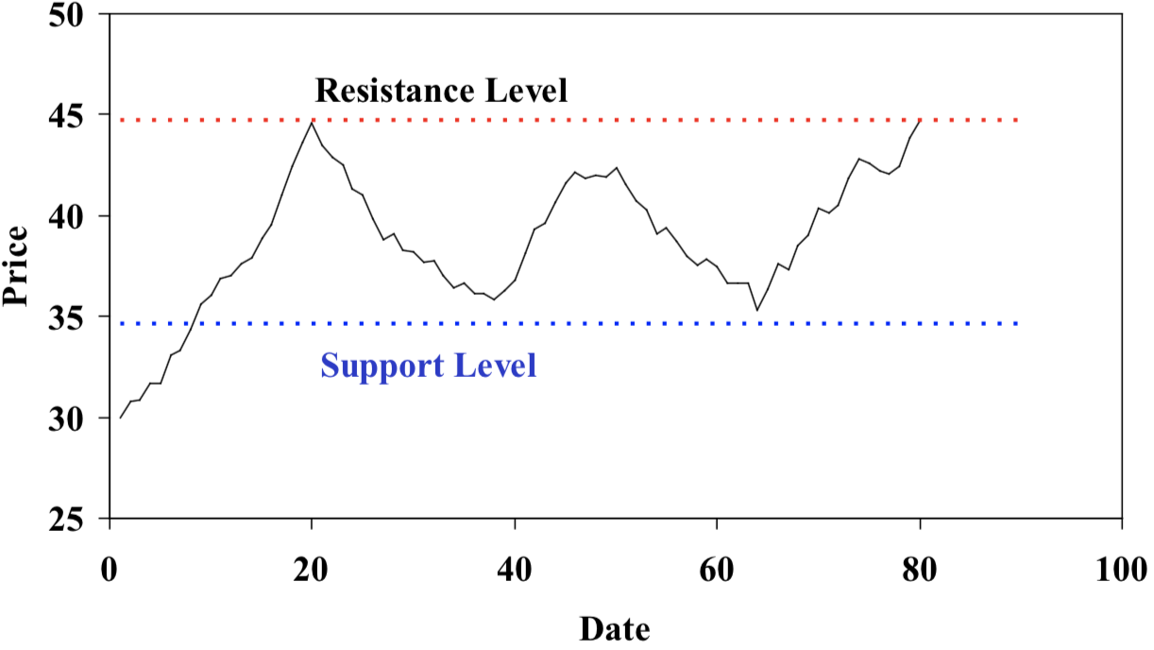

* **Reversal Investors**

Believe that stock price reverses itself in long Run

* **Advances vs Declines**
* **Sentiment Indicator**

If Bullish News Letters < Bearish News Letters 🡪

If “odd lot” buy > “odd lot” sell 🡪

If Shortselling by specialist 🡪

Testing weak Hypothesis 🡪 Evidence shows that the market is efficient in weak form

* **Semi Strong Form Efficiency**

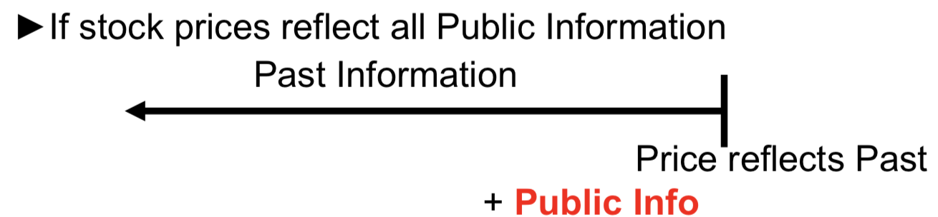

Cannot make extra profit using past and public info

**Fundamentalists** use F/S & other public information to identify mispricing

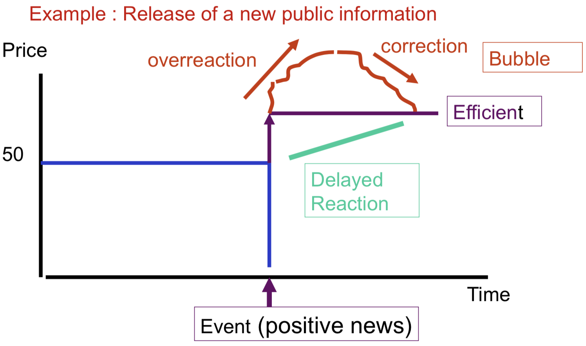

Markets not competitive enough

Contrary to market efficiency

Testing semi-strong form 🡪 Found mixed results (Good fundamental analysis could make money)

* **Strong Form**

If stock prices reflect all information Past + Public + Private

Ex Insider trading seems to earn “abnormal returns” 🡪 strong form NOT possible

**B. Implications of Market Efficiency**

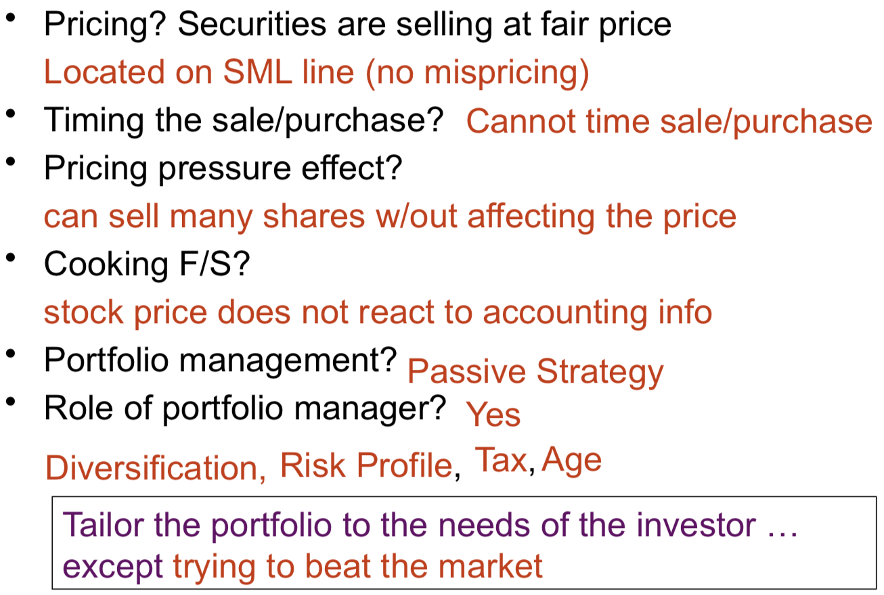

i.e. NOT for making money

e.g. For those with larger tax burden ,prefer capital gain stock --- less tax

Price is only related to cash flow

don’t need to search for stocks(active)

**C. Market Anomalies**

Earn more than market (Market inefficiency)

* Small firms?
* Low P/E?
* High div yield?
* Earning momentum/surprise?
* Neglected firms?
* January effect? (Stock price is higher)
* Institutional holdings?
* Moon effect? (Full moon is higher)